**EUROPEAN LITERACY AND CITIZENSHIP EDUCATION AT SCHOOL**

**Centre culturel Saint Thomas**

**STRASBOURG**

**October 29th–November 1st 2025**

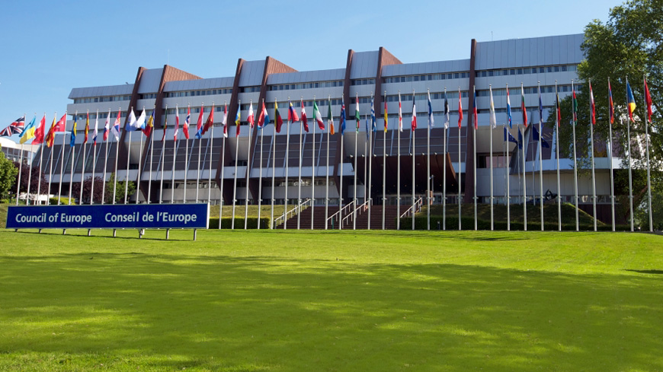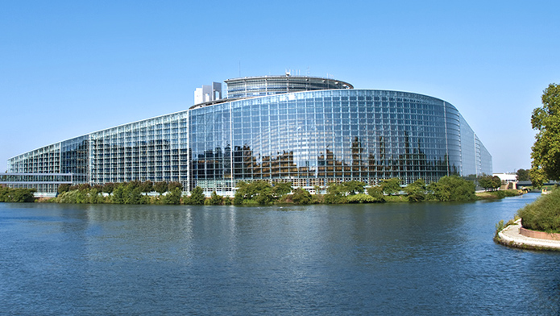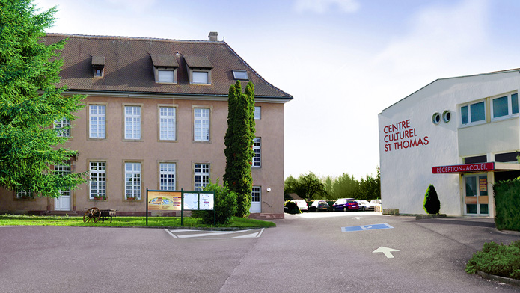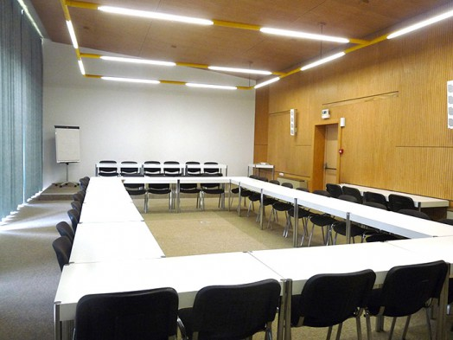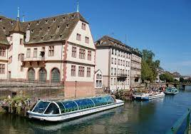

Centre Culturel Saint-Thomas Rue de la Carpe Haute

67000 STRASBOURG

European Parliament

Council of Europe

Batorama

**DETAILED PROGRAM**

|  |  |  |  |  |
| --- | --- | --- | --- | --- |
| **Wednesday 29** | **Thursday 30** | **Friday 31** | **Saturday 1** | **Working hours**  Morning : 9h00-12h00  coffee break 10h30- 10h45  lunch  afternoon 14h-17h  Each theme is introduced by a short video subtitled  **Methods**  self assessment  lecture  group work  role play  problem-base learning  investigations  meetings  visits |
| Arrival participants | 2nd session :**A EUROPEAN LITERACY**  Awareness, identity, citizenship  where do we come from ?  European cilization, roots and heritage | 4th session :**THE CONCEPT OF EUROPEAN CITIZENSHIP**  citiszenship at school  a european citizenship ?  **visit of the european Parliament** | 6th session**:Implementing a european dimension in your teaching** ( following)  Tools and supports usable for an active european teacher  Euroculture : a game to introduce European vlaues  Quiz  Assessment  Certificates |
| 15h opening session  Ice breaking activities | Lunch | Lunch | Lunch |
| Diner | 3rd session :**A EUROPEAN PEOPLE ?**  Which borders ?  Common or share identity ?  **Visit of the council of Europe**  debriefing : How to present Europe to our pupils ? | **5th session : A COMMON EUROPEAN CULTURE ?**  Implementing a european dimension in your teaching :The European Cultural Project  17h :**Discover Strasbourg Batorama** | Departure particpants |
| 1st session :**EUROPEAN IDENTITY IN QUESTION** |
| Diner | Diner in Strasbourg |

**The course fees negotiated with the Saint Thomas Cultural Center are 590 euros per trainee.**

**They include** :

- Accommodation in a single room equipped with WC-showers. ( towels are provided) breakfast included for the 3 nights

- Dinners on February19 and 20

- Lunches on February 20, 21 22

- Coffee breaks

- Training costs: rental of meeting room and equipment, visits and admissions, travel for trainers

- Discover Strasbourg : Batorama

**Not included:**

- travel

- dinner on February 21

**Registration is online at the following address:** [**contact@aede-france.org**](mailto:contact@aede-france.org)

**A complete file including all the information and recommendations for preparing for the internship is then sent to you.**

**This training session can be financed as part of the Erasmus KA 1 mobility program**