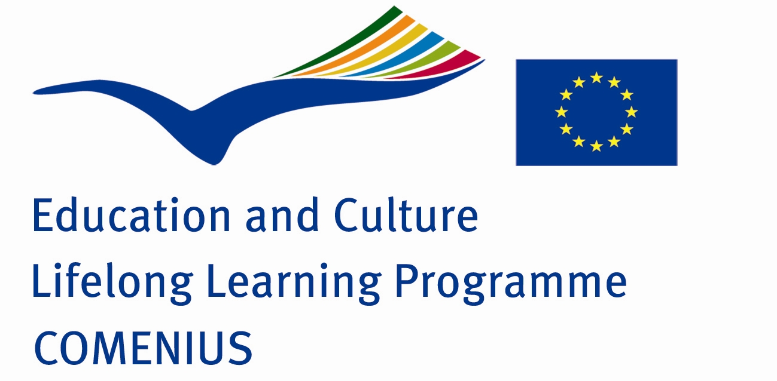

COMENIUS
PROJECT PARTNER FINDING FORM FOR SCHOOL PARTNERSHIPS

We fill the form and hope to cooperate with some other schools

Contact information
Name of the school: | Saldus primary school
School address: | Lielā iela 31/35, Saldus, Saldus novads, LV-3801, Latvia
School telephone: | +371 63807110
Fax: | +371 63807110
Head teacher/ principal: | Dace Balandīna
Coordinator of the project: | Rita Bergmane
E-Mail of contact person: | ritali@inbox.lv
School Website: | www.salduspamatskola.lv
Information about your school
Number of pupils: |  | 350
Number of teachers: |  | 32
Regional characteristics: |  | City x  Rural area   Suburb 
Age of pupils at school: |  | Youngest : 6  Oldest : 16
Age of target group: |  | Pre-primary school   Primary school x  General school x  Secondary school   Technical and vocational school   School for pupils with special education needs   Other :__________________
-Type of school: |  | Primary shool
Describe facilities found in your school (ex; library, sports centre, language rooms, laboratories, history rooms) |  | Rooms : gym, sports field, library,language rooms, art room, computer room.....  Other facilities :  Access : Monday- Friday
Languages taught in your school: |  | Latvian, English, German
Previous experience with international school programmes: |  | Yes :  No x

Project information:
Type of project | Multilateral x Bilateral
Possible title of project
Country Preference
Working language(s) of the project | English
General aim of the project
Subject areas, topics, curriculum areas

Planned outcomes of the project

Any additional information you would like to provide | - for more information please contact at ritali@inbox.lv

