RESERVATION FORM
UNILIM

A booking was made by the ÉSPÉ (University of Limoges) to two hotels very closed to the train station. As the stay is at your charge, please fill this form and send it to us back signed to send to the following addresses
michel.harel@unilim.fr

SUJET :
NETT-Meeting

Customer Information :

Name : First name :

Check in Date: Check out Date : Number of Nights :

Number of People :

Phone Number :

Email Adress :

Hotel information (Fee per night) :
□ Single Room (1 big bed for 1 person): 63,20€ Breakfast and local tax included
□ Double Room (1 big bed for 2 people): 31,20€ per person, Breakfast and local tax included
□ Twin Room (2 small beds for 2 people): 31,20€ per person, Breakfast and local tax included

(A parking space is available for a 5,00€ extra charge)

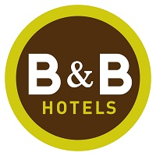
Hôtel B&B Limoges Gare
24 Allée de Séto
87000 Limoges

08.92.70.23.60
bb_4548@hotelbb.com

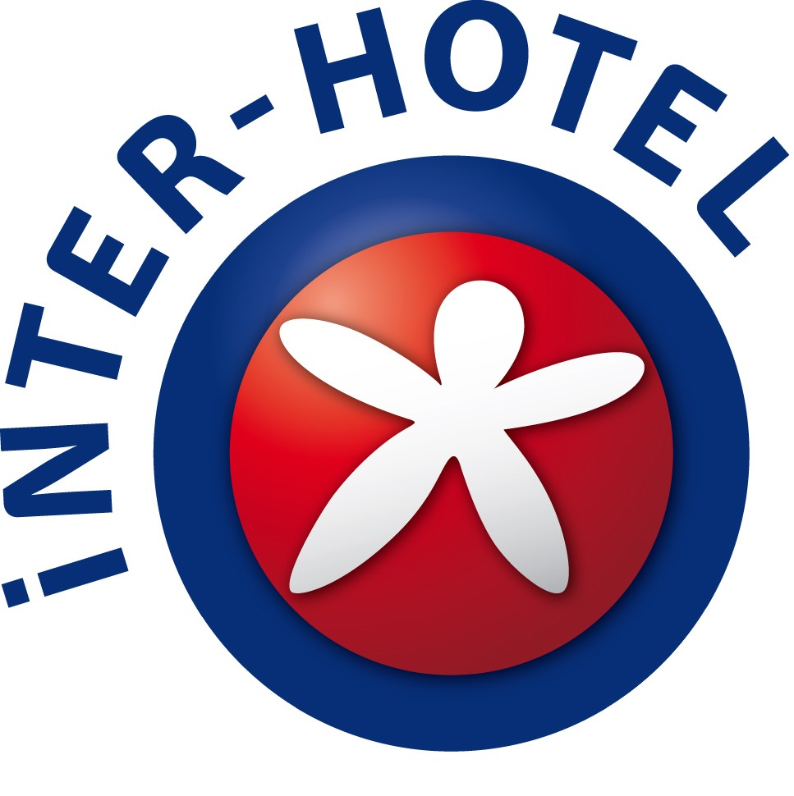

Hotel INTER-HOTEL Informations : (Fee per night)

□ Single Room, (1 big bed for 1 person). Breakfast included. From 14 to 15/06/17 : 105.00 €
From 16 to 18/06/17 : 85.00 €
Local tax : 0.80 € per person and per day

Credit Card Information : (this is just for garanty, you can pay by your choice on check in)
Credit Card :

Visa Mastercard American Express

Credit Card Number:
Expiration Date:
(If the credit card is invalid, the booking won't be confirmed)

Cancellation Terms :
The reservation is cancellable 24h00 before arrival, after this date, the first night will have to be charged. In case of no-show without cancellation, the whole reservation will be charged. (the hotel will debit the credit card)

Date:
Agreement and signature:

